Setting up Zoom Meetings for appointments
When setting up a zoom meeting for an introduction meeting, tax planning, tax preparation,
Email client with a list of three dates and three times for each date of when the prepare is available
Note in original email that all times are PST (pacific standard time)
EX: 1/5: 9am, 10am, 11am
1/6: 1pm, 2pm 4pm
1/7: 10am, 11am, 2pm

In Outlook, select email and chose the calendar option for the person for who you are scheduling for.
Find the date and time of the requested appointment.
Open new appointment
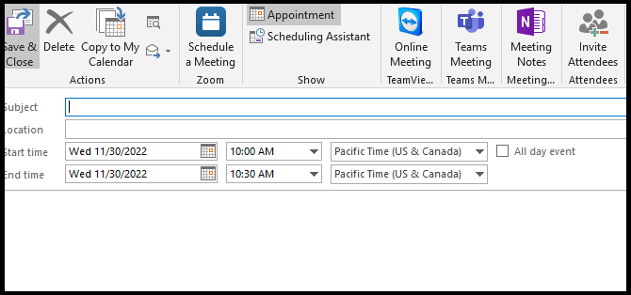
Select “Schedule a Meeting”, this will open the Zoom link,
Log into the Zoom for the correct person.
( See list of Zoom log in User name and passwords)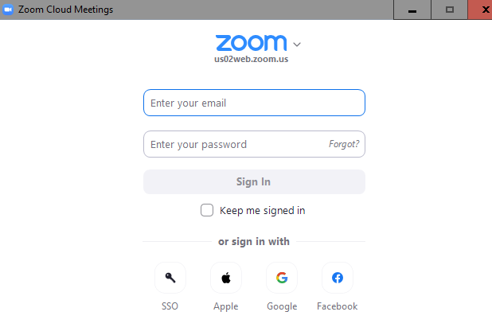
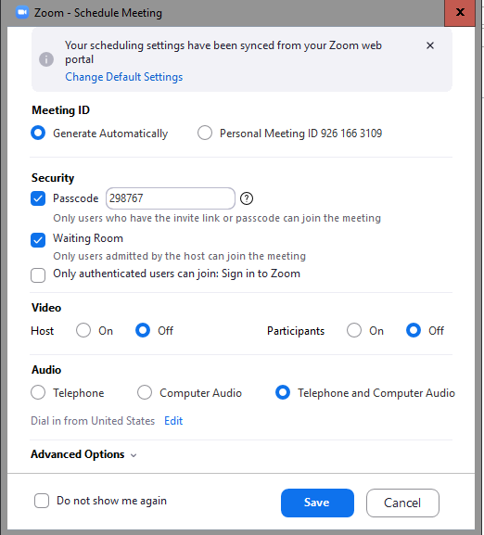
Set the date and time for the appointment.
Meeting should be 1 hour unless specified by the preparer.
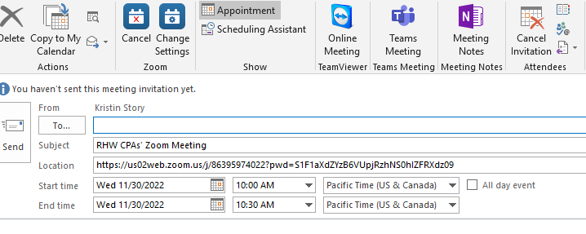
For Chea and Amy, or any prepare that does not work in office in Pleasant Hill office, note time in Pacific Standard Time and Easter Standard time.
Ex: 10am PST
1pm PST
(If need be Google the time difference)

Select :
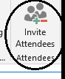
Add any and all clients to the email that will be in attendance to the appointment.

Add any notes pertinent to the appointment, such as a summary of the client questions/concerns and initial the notes.
Included client name and phone number.

In the subject line, title with what the meeting is and the client name
EX: Introduction meeting with John Smith,
Tax Planning with Jane Smith

Send appointment to client,
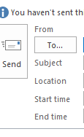
Confirm that appointment with client date and time.

Zoom Log in’s:

Main Account ( Chea)
rhw@rhwcpas.com
RHWCPAs2@

Amy Heck:
aheak@rhwcpas.com
Romine1!

Mark Solorzano:
Msolorzano@rhwcpas.com
RHWCAzoom13

Joseline Madrazo:
jmadrazo@rhwcpas.com
Yz62591!

Cory Cooper
ccooper@rhwcpas.com
Cardinal1

